**Theoretical task**

Java Programming Test 1

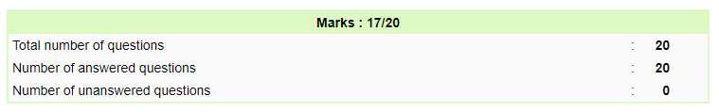

Java Programming Test 2

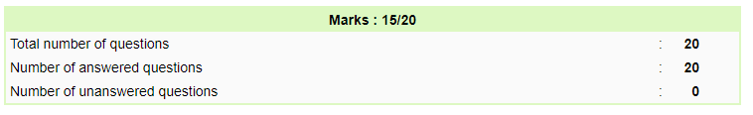

Java Programming Test 3

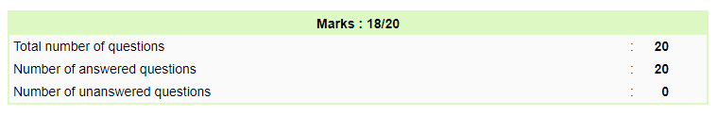

Java Programming Test 4

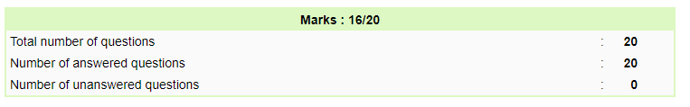

Java Programming Test 5

